Preparatory Russian language course for foreign citizens
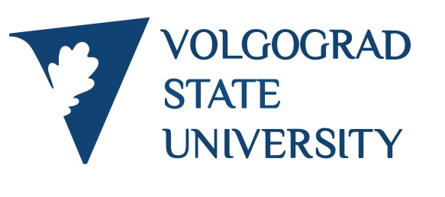
The Russian language course is designed to prepare foreign citizens for their future enrollment in a Russian University to obtain bachelor’s, master’s or Ph.D’s degree in human science, economics, computer and natural science. The teachers of Russian language are highly qualified professionals with experience in teaching foreign students from all parts of the world.

During the learning process you will study different subjects such as reading, writing, listening, speaking, grammar and country history and culture, as well as the subjects corresponding to the profile of your further studies in a Russian University. The Russian language course for beginners is taught in English, so you need to have a sufficient level of English (at least B1). The courses of medium and advanced level are taught in Russian. After completion of the course you will pass final exams and get the certificate of Russian language proficiency.

Duration of study | Period of study | Application deadline | Education fee
Winter semester | September 15 – December 31 | until July 20 | 45 500 rubles
Summer semester | February 15 – June 30 | until December 1 | 45 500 rubles
Academic year (2 semesters) | September 15 – June 30 | until July 20 | 91 000 rubles

Course Duration
 | Date of enrollment
 | from September 15 | from February 15
For students with no / basic knowledge of Russian language (A1-A2) | 2 semesters | 3 semesters
For students with intermediate / advanced knowledge of Russian language (B1+) | 2 semesters | 1 semester
Accommodation
Volgograd State University offers you an accommodation in a dormitory, situated in five minutes’ walk from the University. There are blocks for five persons. Each room is equipped with free Internet access, desks, bookshelves, and single beds. The common is on each floor. The cost of living is about 1500 rubles per month.
Application
To apply for a Russian language course please kitchen fill in the application form on the website: apply.volsu.ru. After your application will be considered, you will get a reply by e-mail. If your application is accepted, you will be sent a Contract for Provision of Educational Services, which you will need to sign, scan, and send us back by e-mail: oms@volsu.ru. Afterwards, you will receive an invoice for payment of the first semester. When the University receives the payment, you will be sent an invitation to obtain a visa to enter the Russian Federation.
Arrival in Volgograd
To enroll the University you will be required the following documents:
- Passport copy
- 6 photos (size 3x4)
- Health certificate and fluorography picture
- Medical insurance (obtainable in Russia)
The dormitory check-in is available on each day of the week by prior arrangement. If a student does not inform about his arrival in advance, the check-in is possible only in the first half of each working day.
Contacts
Web: | www.apply.volsu.ru | Telephone: | +7(8442) 460291 | E-mail: | oms@volsu.ru
Office hours: | Monday – Friday | 9 AM – 4 PM msk

